TIAGO HENRIQUE GOMES DA SILVA BALDUINO

Steps To Test System

**-** the database was used MySql

**-**  create a schema called managementsdb

**-** Execute the following commands:

/*==============================================================*/

/* Table: Department */

/*==============================================================*/

create table `managementsdb`.`Department` (

id INTEGER AUTO_INCREMENT not null,

name VARCHAR(50),

description VARCHAR(50),

constraint PK_DEPARTMENT primary key (id)

);

/*==============================================================*/

/* Table: User */

/*==============================================================*/

create table `managementsdb`.`User` (

id INTEGER AUTO_INCREMENT primary key not null,

name VARCHAR(50),

description VARCHAR(50),

department_id INTEGER NOT NULL );

/*==============================================================*/

/* Table: Permission */

/*==============================================================*/

create table `managementsdb`.`Permission` (

id INTEGER AUTO_INCREMENT primary key not null,

name VARCHAR(50), description VARCHAR(50));

/*==============================================================*/

/* Table: UserPermission */

/*==============================================================*/

create table `managementsdb`.`UserPermission` (

USER_ID INTEGER not null,

PERMISSION_ID INTEGER not null,

primary key (USER_ID, PERMISSION_ID)

);

USE managementsdb;

alter table `managementsdb`.`User`

add constraint FK_USER_REFERENCE_DEPARTMENT foreign key (department_id)

references Department (id)

on delete restrict on update restrict;

alter table `managementsdb`.`UserPermission`

add constraint FK_USERPERMI_REFERENCE_USER foreign key (USER_ID)

references User (id)

on delete restrict on update restrict;

alter table `managementsdb`.`UserPermission`

add constraint FK_USERPERMI_REFERENCE_PERM foreign key (PERMISSION_ID)

references Permission (id) on delete restrict on update restrict;

Make sure that MySQL is using the port: 3306 or switch to the preference at applicationContext.xml line archive: 25

-Make sure that MySQL is using the port: 3306 or switch to the preference at applicationContext.xml line archive: 25

- Have installed Tomcat 8 or wildfly.

- Descompact the downloaded project GIT the link

https://github.com/tiagobalduino/JSF_SPRING_HIBERNATE.git

- Import the project in Eclipse IDE

- To run in wildfly you need to change the project to TargetRuntimes Wildfly in the project properties

- Add the project on your server and run.

C:\Users\Tiago\Desktop\Positivo\Banco de dados\novo

Access link**:** [**http://localhost:8080/JSF_Spring_Hibernate/index.xhtml**](http://localhost:8080/JSF_Spring_Hibernate/index.xhtml)

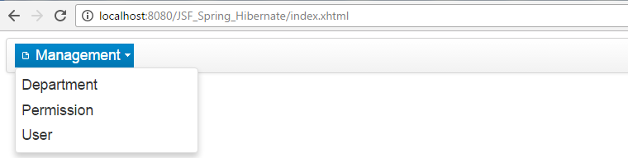

- management Department complete CRUD

- management Permission complete CRUD

-management User complete CRUD